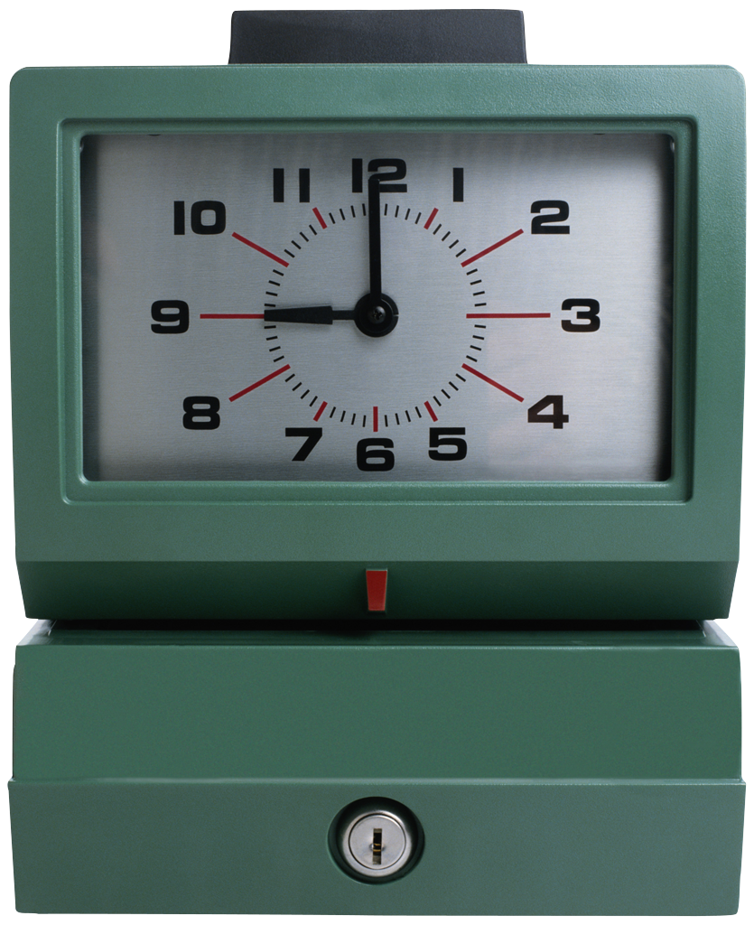

Jewelry

2013-2014

**Daily Expectations:**

✓Be in class when the bell rings. NO RUNNING!

✓**Work in your assigned seat!**

✓No hats, hoods, or electronic devices.

✓Adhere to dress code policies!

✓Have all needed materials for class ***with you***- NO locker passes.

✓Food & beverages are **not** allowed in the art room.

✓Be Respectful…use appropriate language!

✓**Respect art supplies & property! Detentions assigned for damaging supplies/ not doing your cleanup.**

✓***Everyone*** helps with clean up. Do your part! **No lining up at the door-** dismissed by table.

✓ Stay *on task!* Have fun, be creative & do *your* best!

Classroom Management:

**SUPPLIES: Always have a pencil, eraser, & current assignment with you. A bin is provided for students to store their supplies. NO LOCKER PASSES will be written.**

**HALL PASSES: Three passes per trimester! NO passes the 1st and last 10 min. of class.**

**TARDIES: Students will receive either a *lunch* or *after school* detention for every 3 tardies/ *unexcused* late to class.**

**GRADING/ASSESSMENT: Assignments, exercises & tests= Formative-20% (Test retakes within two weeks). Projects & Final exams= Summative-80%.**

**expected to make up work when they miss class. Modifications are made as needed. All work is due at mid *o*r end of the trimester as posted.**

*Osseo Junior High Visual Arts Room 126*

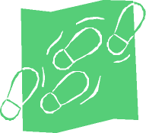

## Class Productivity

# Assignments & Projects List (Tentative)

THE ELEMENTS OF ART & PRINCIPLES OF DESIGN

* Book

WIRE UNIT

* Wire charm bracelet
* Wire Pin or Ring

REPOUSSE UNIT

* Pendant
* Lidded Box

BEAD UNIT

* Bead making
* Braclet

PIERCING UNIT

* Shape within a shape

SOLDERING UNIT

* Soldered ring

CASTING UNIT

* Pendent

ART JOURNALING / READINGS

Students participate in journaling/ readings throughout the course. After examining artworks by artists from various cultures, historical periods and ethnic groups, or completing a reading, students will respond by completing a journal entry or answering a series of questions.

**CONSEQUENCES OF INAPPROPRIATE BEHAVIOR**

1. **VERBAL WARNING**
2. **REMOVED FROM CLASS & CALL HOME**
3. **OFFICE REFERRAL/REMOVED FROM CLASS – CALL HOME**
4. **LUNCH /AFTERSCHOOL DETENTION**
5. **BEHAVIOR PLAN WITH FURTHER CONSEQUENCES.**

Students are expected to utilize class time efficiently. Projects and assignments are to be completed in class. Homework is not assigned outside of class time during the Trimester, *however* may be necessary based on student productivity or due to lost class time. Students are encouraged to spend *any* quality time they have to complete their assignments and projects. ***Afterschool*** make up times are available weekly on a sign-up basis.

**Trimester 2**

1st Hour ~ Art 7

2ndHour ~ Art 8

3rd Hour ~ Art 8

4th Hour ~ Art 8-day 1 Art 7-Day2

5th Hour ~ *Art 7*

6th Hour ~ *Jewelry*

Instructor:

Mr. Wiken

***Phone:*** (763) 391-7700

***Email:*** wikenp@district279.org