Photoshop Tutorial: The Hedcut Effect
Hedcut is a style of drawing, primarily of people, pioneered and used by The Wall Street Journal. The drawings are traditionally 18 by 31 Picas (3″ by 5.167″), and use the stipple method of many small dots to create an image. They are designed to emulate the look of woodcuts from old-style newspapers, and engravings on certificates and currency. The phonetic spelling of “hed” may be based on newspapers’ use of the term “hed” for “headline.”

1. I’m going to start with an image that I pulled off of Google Images:
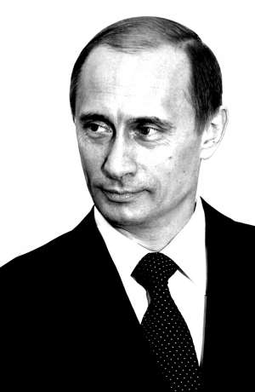
I chose this image primarily because it has a white background. It’s always easier to work with pictures with plain backgrounds especially if you want to edit only its subject. Note that this tutorial applies to black and white images. To convert a picture to black and white, click Image > Adjustments > Desaturate. If the picture doesn’t have enough contrast, click Image > Adjustments > Brightness and Contrast to increase contrast. To take advantage of the stipple effect, we need contrast to define the light areas from the dark areas.
2. Next, choose the Pencil tool and set the diameter to 5px and 100% opacity. Zoom in on your image to begin creating a set of dots. Our dots will each have a 5 x 5 pixel diameter and will be just 2 pixels apart. Depending on the size of your image, you may have to adjust the diameter and spacing.
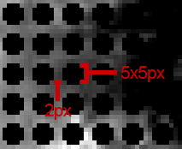
To make things easier, keep duplicating layers until you’ve created enough dots to cover four times the size of your canvass.
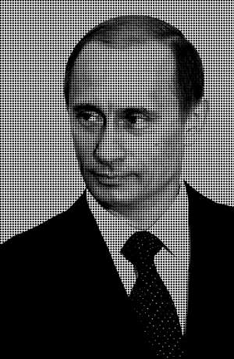
For the sake of this tutorial, name this layer “Dots” and the other layer “Putin”.
3. With the Dots layer currently selected, click Filter > Distort > Wave. By doing this, we’re creating a more randomized pattern of dots that will help accomplish the stipple effect. Copy the following settings:
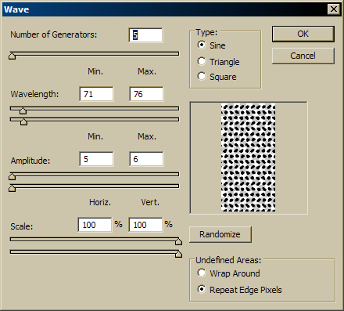
Click OK to apply the filter. Your image will look something like this:
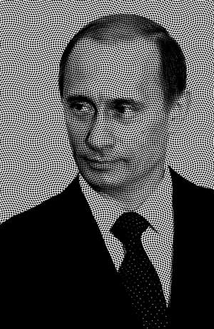
If you find that the dots are too big, you may resize them through Edit > Transform > Scale. Be sure to press the Shift key to maintain proportion. I chose to scale down my dots by about 15%.
4. In the next step we apply a mask to the Dots layer to reveal only the parts of the dots that are shaded/darkened on Putin’s face. To do this, duplicate the layer with Putin’s picture and arrange it in this manner:
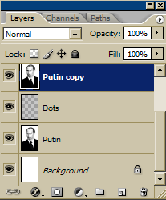
Apply a layer mask to the Dots layer by clicking Layer > Layer Mask > Reveal All. Select the Putin Copy layer and click Layer > Create Clipping Mask. This becomes the mask for the dots.
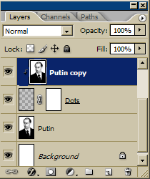
5. With the Putin Copy layer currently selected, click Image > Adjustments > Curves. Play around with the line graph and see the mask taking effect. These were my final settings:
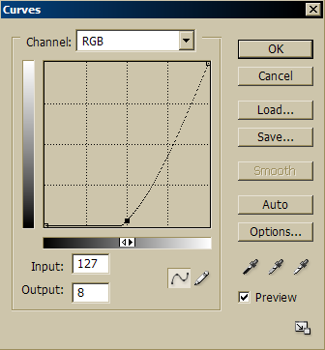
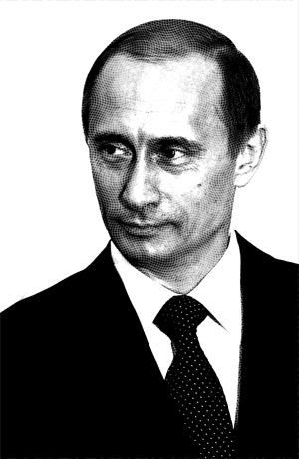
6. Now you’ll notice that the dots have somehow obtained a polygonal shape. What we really want are circular dots. To get around this, first merge the three layers Putin Copy, Dots and Putin through Layer > Merge Down or Ctrl-E. Then, click Filter > Artistic > Poster Edges.
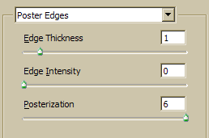
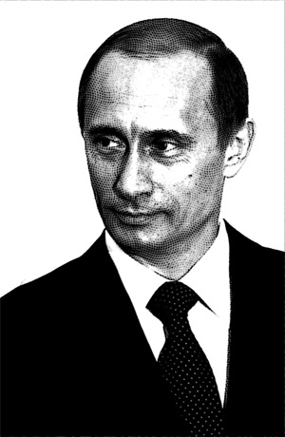
7. With a bit more tweaking, this is my final output:
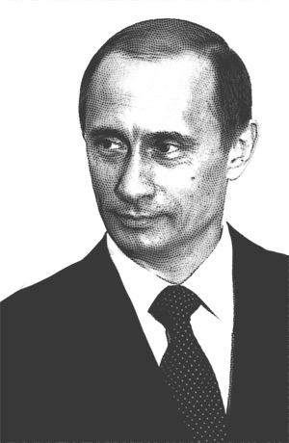
I increased the brightness just a bit and cleaned up the border mess caused by Poster Edges.
Sometimes it looks quite a bit mechanical because it was created through a computer which is unavoidable. But as you reduce the image size the dots become less obvious, making your work more convincing.
Download the source file (2mb) here.
Here’s more:
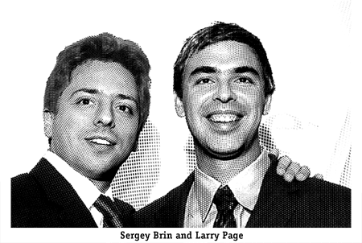
Google founders Sergey Brin and Larry Page: I used different patterns for the hair, face, body and background.
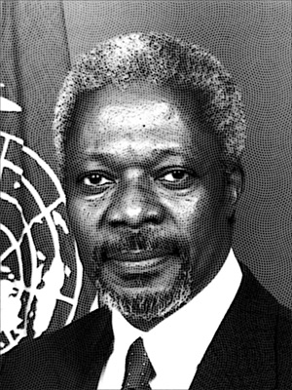
Outgoing United Nations Secretary-General Kofi Annan

