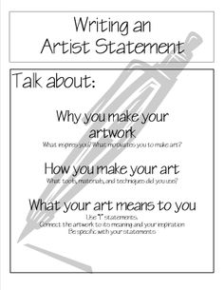
What is an Artist’s Statement?
- Basic Written Introduction to your Art
- Includes Essential Facts
- Uses Language Anyone can Understand
Artist’s Statement Ideas
- Why you make your art
- What inspires you to make it
- What it signifies or represents
- What’s special about how you create it
- What your art means to you
Artist’s Statement Protocol
- Entice readers to want to know more about your art
- Don’t give too many details but be specific
- Write in 1st person—lots of “I” or “My” statements
Artist’s Statement Example
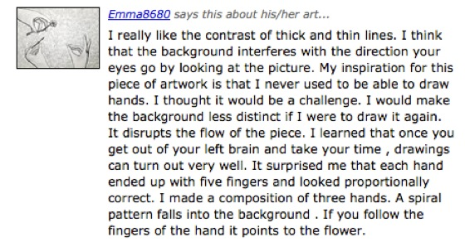
http://www.bing.com/videos/search?q=artist+statement&FORM=HDRSC3#view=detail&mid=47F1BA8DC587405E9F3C47F1BA8DC587405E9F3C
http://www.youtube.com/watch?v=18aDtU7QbRk
http://vimeo.com/68177758
http://vimeo.com/22092187

